Togo

## GNI per capita and development level

The data set shows the GNI per capita and development level of the country each year.

## # A tibble: 19 x 5  
## country iso3c date GNIperCapita devCategory  
## <chr> <chr> <dbl> <dbl> <chr>   
## 1 Togo TGO 1996 546. Low Income   
## 2 Togo TGO 1998 575. Low Income   
## 3 Togo TGO 2000 546. Low Income   
## 4 Togo TGO 2002 546. Low Income   
## 5 Togo TGO 2003 569. Low Income   
## 6 Togo TGO 2004 547. Low Income   
## 7 Togo TGO 2005 509. Low Income   
## 8 Togo TGO 2006 509. Low Income   
## 9 Togo TGO 2007 491. Low Income   
## 10 Togo TGO 2008 501. Low Income   
## 11 Togo TGO 2009 514. Low Income   
## 12 Togo TGO 2010 530. Low Income   
## 13 Togo TGO 2011 586. Low Income   
## 14 Togo TGO 2012 575. Low Income   
## 15 Togo TGO 2013 597. Low Income   
## 16 Togo TGO 2014 618. Low Income   
## 17 Togo TGO 2015 653. Low Income   
## 18 Togo TGO 2016 656. Low Income   
## 19 Togo TGO 2017 662. Low Income

## GDP growth and economic growth classification

The data set shows the GDP growth and the ecomic growth classification of the country each year.

## # A tibble: 19 x 5  
## country iso3c date GDPannualGrowthRate GDPgrowthCategory4  
## <chr> <chr> <dbl> <dbl> <fct>   
## 1 Togo TGO 1996 8.84 fast growth   
## 2 Togo TGO 1998 -2.30 negative grwoth   
## 3 Togo TGO 2000 -0.783 negative grwoth   
## 4 Togo TGO 2002 3.83 moderate growth   
## 5 Togo TGO 2003 6.72 fast growth   
## 6 Togo TGO 2004 -0.979 negative grwoth   
## 7 Togo TGO 2005 -4.67 negative grwoth   
## 8 Togo TGO 2006 2.65 moderate growth   
## 9 Togo TGO 2007 -1.18 negative grwoth   
## 10 Togo TGO 2008 4.06 moderate growth   
## 11 Togo TGO 2009 5.54 fast growth   
## 12 Togo TGO 2010 6.10 fast growth   
## 13 Togo TGO 2011 6.40 fast growth   
## 14 Togo TGO 2012 6.54 fast growth   
## 15 Togo TGO 2013 6.11 fast growth   
## 16 Togo TGO 2014 5.92 fast growth   
## 17 Togo TGO 2015 5.74 fast growth   
## 18 Togo TGO 2016 5.56 fast growth   
## 19 Togo TGO 2017 4.36 moderate growth

## Development trend

The plot shows the development trend of the country.

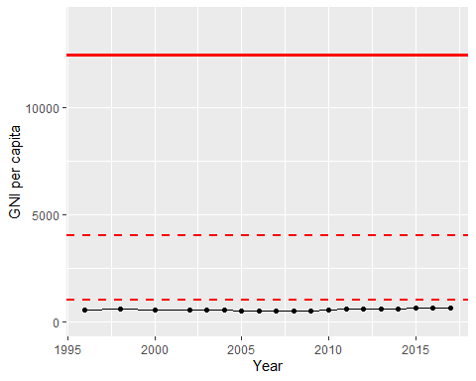

GNI Per Capita Trend